FOX NEWS FLASH

Published February 22, 2023 11:00am EST

'Incredible' stories of healing, reconciliation emerge from Christian revival at Kentucky college

https://www.foxnews.com/media/incredible-stories-healing-reconciliation-emerge-christian-revival-kentucky-college

Ainsley Earhardt speaks to young worshippers at Asbury University
By Madeline Coggins | Fox News
Email

Asbury revival attendees share stories from two-week worship service: Everyone was ‘touched’
'Fox & Friends’ host Ainsley Earnhardt speaks with Asbury University revival attendees Kiersten Williamson and Khalil Akiky about their experiences over the past two weeks.
After roughly two weeks, Asbury University is downsizing the nonstop worship service many have called a "revival."
Due to an overwhelming amount of visitors flooding into the Kentucky campus, the service is now being limited to evenings for 16 to 25-year-olds after Monday's service concluded the "public worship service" of the event.
Even though the event has scaled down, attendees of the event shared with "Fox & Friends" host Ainsley Earhardt stories from their time over the past 13 days.
Asbury University senior Charity Johnson was a singer in the gospel choir who helped kickstart the event during a Wednesday worship service two weeks ago.
"The gospel choir was blessed to lead worship that particular day, and a couple of us were asked to just sing, during the altar call, and we're singing one of our worship songs. And the worship just never stopped," Johnson shared.
"The pianist, my gospel choir director kept playing. One of our members kept singing, and people just started coming to the altar and just repenting."
"And it was just beautiful because the friends that just supported one another was what captivated me."
ASBURY UNIVERSITY ENDS 24/7 REVIVAL MEETING AFTER 50K FLOCK TO KENTUCKY TOWN OVER 13 DAYS
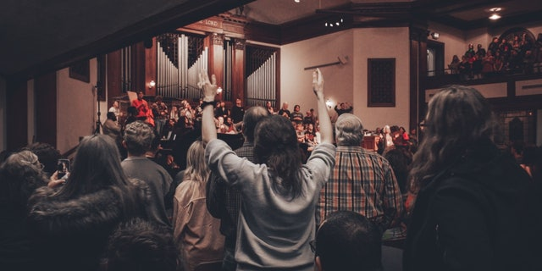
Students raise their hands during a service in the chapel at Asbury University, which has seen participants flocking in nationwide to witness its revival. (Asbury University )
Another Asbury student Khalil Akiky said it is "hard to describe and put into words what you've seen, but I think what I've seen is just like the true goodness of God and the true outpouring of the spirit."
What started as a campus event exploded into a massive movement drawing in attendants from states across the nation as well as countries across the globe. States such as Arizona and Ohio were represented as well as countries including South Korea, Netherlands, Australia, Brazil and Russia.
One international student shared his reaction to the event.
"I am really just happy and just joyful that this has happened because it proves that this is our faith. It's not our parents' faith," Canaan Yan said. "And then, though many of us are second or third-generation Christians, this is something that we believe in and that it has happened in our campus."
The event also drew a crowd of attendees from across ages and generations. One high school senior Kiersten Williamson drove almost daily from Ohio to join in worship. She shared stories of healing from the event.
"We have seen people just go up to people to pray for them," she said. "Even yesterday, I saw a girl take off her boot. She had a sprained ankle. A guy came back in line, prayed for her. She threw it off, started running and just weeping for what God had done for her. And she said it didn't hurt anymore."
ASBURY REVIVAL: PROFESSOR CALLS FOR END TO ‘PUBLIC PHASE’ AS SCHOOL SCRAMBLES TO ADDRESS OVERCROWDING
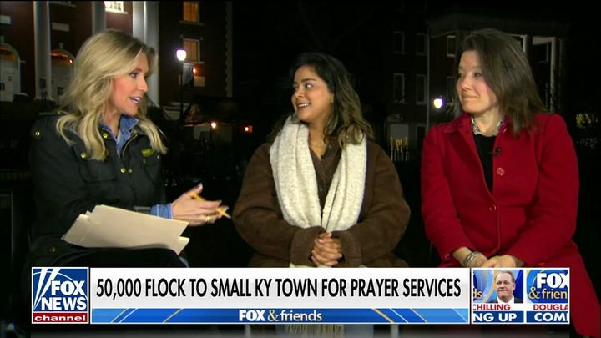Video
"Just incredible things. My friend, last night. Her parents are divorced, and actually, a girl came up to her and said, I have a word of knowledge from you, from God. And she said that, I've seen your past. I've seen everything you went through. He's like, I've been with you through it all. And just a girl she didn't even know. And just she was so touched by that."
"People are getting so touched."
Akiky echoed Williamson's experience, noting how the event spurred on "lots of reconciliation."
"We've seen people healed. I've seen lots of reconciliation, which has been a really awesome cornerstone of what's going on here. And so I've seen people that have very much not liked each other, and we know this, and then they're praying and dancing and worshiping together. And so, yeah, like I said, life's changed, healings, lots of confessions and just prayers," Akiky said.
"I've just seen a humility like no other and people just giving their life and that no matter who you are, what you are, when you are, when you're in the presence of God, we're all the same. We're all the same under Christ."
Despite the overwhelming success of the event, an Asbury freshman unpacked the decision to downsize the event and acknowledged the new momentum for sharing their experience.
"We really believe like one, the sustainability we needed to like be doing it in a healthy manner for students and faculty, but also just like refocusing on this commissioning and the sending of all of these people that have come here," freshman Ava Miller said.
"But now it's about like, let's go share the gospel and this beautiful message."
Fox News' Timothy H.J. Nerozzi and Jon Brown contributed to this report.
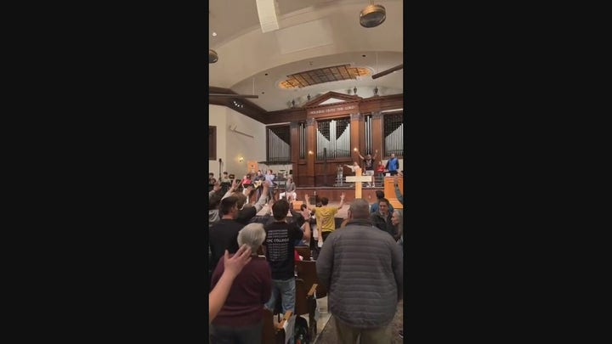Video
Madeline Coggins is a Digital Production Assistant on the Fox News flash team with Fox News Digital.

